Tentative title: Molecular diversity informed modeling of litter decomposition

Arjun Chakrawal1*, Luciana Chavez Rodrigez2, Stefano Manzoni3, Satish Karra1, Odeta Qafoku1, and Emily Graham1

1Environmental Molecular Sciences Laboratory, Pacific Northwest National Laboratory, Richland, WA, USA

2Soil Biology Group, Wageningen University & Research, Wageningen, Gelderland, The Netherlands

3Department of Physical Geography and Bolin Centre for Climate Research, Stockholm University, 10691 Stockholm, Sweden

Journal outlet: JGR: Biogeosciences, Journal of Advances in Modeling Earth Systems, Springer Biogeochemistry, Plant and Soil

#Corresponding author; email address: [arjun.chakrawal@pnnl.gov](mailto:arjun.chakrawal@pnnl.gov)

**Total word count: 5788**

Introduction: 1046

Material and Methods: 2710

Results: 857

Discussion: 1319

Conclusion: 126

**Display items**

Number of Figures: 8

Number of Table: 1

**Supplemental Materials**

Supplemental Figures: 6

Supplemental Tables: 3

**Abstract (cut to 250 word)**

Predicting litter decomposition remains a central challenge in biogeochemical modeling. Traditional models of litter decomposition lack the chemical resolution necessary to capture intra-molecular interactions like the shielding of carbohydrates and proteins by lignins, which creates a bottleneck during decomposition, and do not describe microbial responses to specific compound classes. Solid-state ¹³C Nuclear Magnetic Resonance (NMR) spectroscopy offers molecular-level resolution of litter composition, which can help constrain decomposition models—yet its potential has not been fully exploited. Here, we develop a chemically resolved litter decomposition model informed by ¹³C NMR-derived compound classes—carbohydrates, proteins, lignins, lipids, and carbonyls—to evaluate how litter chemistry and microbial physiologyinfluence decomposition dynamics. We synthesized data from 17 studies reporting temporal changes in litter mass and NMR spectra across 89 litter types . Four model scenarios were tested, varying in their treatment of lignin protection and the metabolic cost of oxidative enzyme production. Calibrating four model scenarios yielded strong agreement with observed mass loss across chemical classes (Nash–Sutcliffe modeling efficiency > 0.95). While the inclusion of a lignin-specific rate modifier did not universally enhance predictive accuracy, it enabled mechanistic representation of microbial trade-offs between enzyme allocation and substrate decomposition. In scenarios incorporating enzyme production costs, the initial carbon use efficiency and nitrogen retention were reduced, consistent with theoretical expectations under nutrient-limited conditions. These findings demonstrate that models resolving different compound-classes, and constrained by ¹³C NMR data, represent effectively chemically mediated microbial processes and can inform next-generation soil biogeochemical models of organic matter turnover and nutrient cycling.

**Keywords:**

chemodiversity, decomposition, 13C NMR, plant litter, degree of reduction, carbon use efficiency

# Introduction

Existing soil biogeochemical models face challenges in integrating the coupled dynamics of multiple elements (carbon–C, nitrogen-N, phosphorous-P) and of the chemical composition of organic matter as informed by emerging molecular-scale data (Kothawala et al., 2021). The application of high-resolution mass spectrometry techniques such as Nuclear Magnetic Resonance (NMR) and Fourier Transform Ion Cyclotron Resonance mass spectroscopy (FTICR-MS) is elucidating the chemical composition at molecular scale of organic matter in soils (Boye et al., 2017; Dignac et al., 2002; Ding et al., 2020; Hall et al., 2020; Normand et al., 2021; PRESTON et al., 1987), plant litter (Bonanomi et al., 2013; Preston et al., 2000), and microbial biomass (Hedges et al., 2002; Knicker and Lüdemann, 1995). Despite advances in characterizing organic matter at the molecular scale, this new information stream has not been exploited in biogeochemical models. For instance, while solid-state 13C NMR has been extensively utilized to investigate the influence of plant litter quality on its degradation, the direct integration of NMR data into litter decomposition models remains limited (Bonanomi et al., 2013; C.M. Preston et al., 2009). This study introduces a novel approach to model litter decomposition model that is informed and constrained using solid-state 13C NMR data.

Capturing changes in chemical composition is key for predicting decomposition rates. In fact, the complex and heterogeneous structure of lignin in plant cell walls provides a protective barrier for high-energy unbranched carbohydrates, such as cellulose, and cross-linked polysaccharide chains, like hemicellulose, that are housed within plant cells. These lignin compounds shield carbohydrates as well as proteins from microbial decomposition. Chemical constraints on access to high-energy substrates have been modeled using a rate modifier that decreases the uptake rate of carbohydrates and proteins with increasing lignin content in plant litter. Certain specialized decomposer organisms, including white-rot fungi and Agaricomycetes, have oxidative enzymatic capabilities and thus can break down lignocellulosic bonds in plant cell walls, releasing polysaccharides for microbial growth and respiration (Alcalde, 2015; Mattila et al., 2022). However, producing and maintaining the functionality of oxidative enzymes require significant resource investment by microbes that would otherwise be used for growth (Moorhead et al., 2013; Shimizu et al., 2005). These costs can be accounted for by reducing microbial C use efficiency (Manzoni et al., 2021; Moorhead et al., 2013). These competing processes generate a trade-off between the capacity to access resources and the capacity to convert such resources into biomass.

To describe this trade-off and its consequences for soil carbon budgets, a detailed chemical characterization of litter is needed. Such a characterization would allow describing in the model the chemical compounds that are directly involved in the shielding effect, as well as the enzymatic reactions that break them down. Moorhead et al. (2013) found that the decay rate of holocellulose (cellulose and hemicellulose) decreases while that of lignin increases with the lignocellulose index (lignin/(lignin + holocellulose)) during litter decomposition. This effect is captured by a rate modifier that reduces the decomposition rate constants at high lignocellulose index values. Such an approach has been applied in LIDEL (Campbell et al., 2016) and MEMS models (Robertson et al., 2019). Building on Moorhead et al. (2013), Manzoni et al. (2021) employed a power law function to incorporate the diminishing rates of carbohydrates and protein pools in their model. However, these and other decomposition models (e.g., (Liski et al., 2005)) rely on a coarse characterization of litter chemistry based on proximate analysis, which does not reflect litter chemical composition and lacks the resolution for a mechanistic description of the lignin shielding effect. In fact, the acid unhydrolysable and hydrolysable fractions from proximate analysis of plant material can only be used as proxies for lignin and carbohydrates, respectively, but they do not represent accurately the actual carbohydrate and lignin fractions (Chakrawal et al., 2024b; Preston and Trofymow, 2015). As a consequence, using proximate analysis for parameterization of the rate modifier function has posed significant challenges particularly due to measurement errors inherent in quantifying lignin and carbohydrates.

To overcome these parameterization challenges, some models are now turning to NMR data to gain mechanistic insights on the chemical constraints on decomposition. Recently, Chakrawal et al. (2024a) utilized the lignin fraction derived from 13C NMR spectra data in a rate modifier to slow down decomposition. We are aware of only one other study by Incerti et al. (2017) that directly utilizes 13C NMR data to inform and constrain a litter decomposition model, termed OMDY (organic matter dynamics). The rate modifier in the OMDY model is referred to as an intramolecular protection function that decreases the rate of decomposition of the simulated litter pools with increasing fractions of pools considered to have a protective effect. OMDY considered four litter pools in based on four molecular group identified from 13C NMR spectra chemical shift regions—alkyl C (0–45), methoxy and N-alkyl C (46–60), O-alkyl C (61–90) and di-O-alkyl C (91–110)—of which alkyl C, O-alkyl C and di-O-alkyl C have a protective effect.

As detailed chemical composition of plant litter becomes available, we can also ask whether such empirical rate modifier and associated cost of oxidative enzyme production are still required for model parameterization. To address these multiple challenges (matching modelled and measured quantities; describing the lignin shielding mechanism; modeling enzymatic reactions), there is scope for developing a litter decomposition model that can be informed using detailed molecular scale chemical composition together with mass and nutrient loss data.

In this contribution, we demonstrate the integration of molecular-scale chemical composition of plant litter, specifically utilizing solid-state 13C NMR, to constrain coupled C and N litter decomposition models. Our model simulates litter decomposition dynamics by tracking mass loss in five constitutive fractions—carbohydrates, proteins, lignins, lipids, and carbonyls. We used this model to assess the efficacy of ¹³C NMR data in calibrating four model scenarios that differ in their representation of (i) the protective effect of lignin on carbohydrate and protein degradation, and (ii) trade-offs in microbial carbon use efficiency (CUE) due to costs associated with oxidative enzymes. Our specific research questions are as follows:

1. Does a lignin rate modifier improve model performance after calibration?
2. Can we use 13C NMR data to constrain litter decomposition model parameters?
3. How do estimated parameters vary across four model scenarios constrained using the same litter decomposition dataset?
4. Can NMR constrained model reproduce the previously reported decline in microbial CUE with increasing C:N ratio of litter?

# Methods

## Data collation and preparation

We searched published literature for litter incubation studies either in lab or field condition reporting litter total C and N mass loss and spectra from solid state 13C NMR over time. In total, we included 17 studies spanning 89 litter samples collected from warm and cold temperate and Mediterranean climate (SI Figure S1). The incubation length varied between 6 months (Mediterranean sites (Bonanomi et al., 2013)) to 6 years (Canadian intersite decomposition experiment sites, (Caroline M. Preston et al., 2009)), accounting for total mass loss in the range of 20-98% of starting litter mass. Furthermore, the entire dataset covered a wide variety of litter types such as leaves of broadleaf trees, conifers, crops and other grasses, roots, and wood. The details of initial litter chemical composition, duration of field exposure or incubation length, mean annual temperature and precipitation, and initial fraction of organic compound classes obtained from NMR data are summarized inTable 1.

Mass loss data for C and N were digitized from published studies or provided by authors. The 13C NMR data are usually reported as integrated values of seven chemical shift regions (alkyl, methoxy, o-alkyl, di-o-alky, aromatic, phenolic, carbonyl, see Figure 1A) and directly digitized from the tables of the source studies. We considered only those studies that reported NMR data of integrated chemical shift in a tabular format, i.e., the spectrum itself was not digitized. The integrated values of chemical shift regions are a quantitative measure of various functional groups of organic C present in the litter sample (Figure 1A), and can be used to estimate molecular scale chemical composition of litter. For example, the sum of di-O-alkyl and O-alkyl is indicative of carbohydrates, while aromatic and phenolics are indicatives of lignin like compounds (Kögel-Knabner, 2002). The integrated values of the seven chemical shift regions are often normalized with the total area under the spectra to represent the fraction of C of each functional group out of the total litter C. The integrated chemical shift data can be transformed into fractions of five distinct molecular classes of compounds using a molecular mixing model (Nelson and Baldock, 2005). These classes are carbohydrates, proteins, lignins, lipids, and carbonyls. The molecular mixing model is described in detailed in the following section.

## Molecular mixing model

Assuming plant litter samples consist of carbohydrates, proteins, lignins, lipids, and carbonyls , the molecular mixing model estimates the fractions of each class such that the observed solid state 13C NMR spectra of whole litter sample is a weighted sum of the spectra of the organic compounds (Figure 1A). The elemental composition of these organic compounds is fixed (see SI Table S1). Thus, the input data required for the molecular mixing model is the observed integrated values of the chemical shift regions of the litter sample (${NMR}_{Litter}$) and the organic compounds (${NMR}_{OC}$). Let us denote the C fraction of a molecular class as $x_{i}$ in units of gC per gC of litter, where $i$ indicates carbohydrates, proteins, lignins, lipids, or carbonyls. Mathematically, the molecular mixing model can be written as,

|  |  |  |
| --- | --- | --- |
|  | $${NMR}_{OC}×x={NMR}_{Litter},$$ | (1) |

where ${NMR}_{OC}$ is a matrix of size [$7×5$] whose rows are the NMR spectra of the seven chemical shift regions of the five organic compounds, $x$ is a column vector of size [$5×1$] containing the fractions of the five organic compounds, and ${NMR}_{Litter}$ is a column vector of size [$7×1$] containing the observed integrated values of the seven chemical shift regions of the litter sample. Equation (1) is solved for $x$ using total C and N concentration of litter as constraints to conserve mass. If the litter C:N ratio $CN_{litter}$ (gC /gN) was reported, then protein fraction is constrained using the whole litter N mass balance i.e., $x_{P}=\frac{CN_{P}}{CN_{litter}},$ where ${CN}_{P}=3.2$ is the C:N ratio of proteins—indicating that all the litter N is found in proteins. For more details on the molecular mixing model, see Chakrawal et al. (2024b). The molecular mixing model is used at each time point to convert NMR chemical shift data to C fractions of carbohydrates, proteins, lignin, lipids, and carbonyls, which can then be converted into mass unit (gC) multiplying the fractions by the total litter C (gC). We used scipy.optimize.minimize function (CITE) with mass balance constraints to solve for $x$. If the C:N ratio of the litter sample was not reported, then the N mass balance constraint was dropped and $x_{P}$ was estimated simultaneously with the other fractions using optimization. Toassess the molecular mixing model performance, we calculated Nash–Sutcliffe modeling efficiency coefficient (NSE) and root mean squared errors (RMSE) by comparing the observed chemical shifts from NMR to those calculated using the estimated $x$ (SI Figure S2).

## Litter decomposition model

We developed a litter decomposition model for simulating the dynamics of C and N within five distinct pools representing organic compounds as identified from the molecular mixing model using NMR data (Figure 1B). We assumed first order kinetics for the uptake rate ($U_{i}$) of each pool, which is reasonable when using coarse time resolution data spanning months-to-years. The protection effect of lignin on carbohydrates and proteins is implemented using a sigmoidal function ($p$) that decreases with increasing fraction of lignin similar to Chakrawal et al. (2024a). Further, we assumed that assimilated substrates can be used for growth and maintenance at a maximum C use efficiency (${CUE}_{max}$) as a function of the C oxidation state of whole litter. The maximum CUE decreases with increasing decay constant for the lignin fraction in model variants accounting for the C investment into oxidative enzyme production (Manzoni et al., 2021).

Figure 1 (A) Observation model schematic illustrating the preprocessing of solid-state 13C NMR spectra through a molecular mixing model to derive fractions of five major components of litter, namely, carbohydrate, protein, lignin, lipid and carbonyl. (B) Litter decomposition model schematic wherein microbes decompose various litter components with an overall CUE. Solid and dashed lines denote substrate uptake rates ($U_{i}$) and microbial mortality rates ($m_{i}G$) of respective pools, where $i$ = ( $C_{h}, P, L_{g},L_{p}$ or $C_{n}$), $G$ is the microbial growth rate, $m_{i}$ is the fraction of necromass recycled into pools, and $C$ in $C_{i}$ denote carbon in mass units (gC). $M_{net}$ is the net N exchange rate from inorganic N pool, i.e., the difference between rates of N supply and microbial N demand.

Under N-limited conditions occurring when the protein content is too low to fulfill microbial N requirement, we consider two alternative strategies: i) microorganisms preferentially retain N when they senesce (Manzoni et al., 2021) or ii) microorganisms regulate their CUE via overflow respiration, resulting in decreased CUE (Schimel and Weintraub, 2003). Furthermore, we assume that microorganisms grow in a quasi-steady state condition, meaning their growth rate equals mortality rate. The necromass is recycled into various organic compound classes according to its composition, i.e., a fixed fractions of necromass is distributed across pools under C limited conditions, or with variable fractions under N limited conditions when strategy i) is adopted.

2.3.1 Carbon balance equations

Based on the general assumptions described above, we can write the mass balance equation for C in each organic compound class as follows:

|  |  |  |
| --- | --- | --- |
|  | $$\frac{dM_{i}}{dt}=-U_{i}+ m_{i}T,$$ | (2) |

where $M$ is the mass of C in each pool, $i$ = $C_{h}, P, L_{g},L_{p}$ or $C_{n}$ for carbohydrates, proteins, lignin, lipids, and carbonyls, respectively. The coefficients $m_{i}$ are the fractions of microbial mortality rate $T$, recycling into the respective substrate pools ($\sum{m_{i}}=1$). The uptake rate from each pool $U_{i}$ is prescribed using first-order kinetics with $v_{i}$ as rate constant, and is expressed as:

|  |  |  |
| --- | --- | --- |
|  | $$U_{i}=p_{i}v_{i}M_{i},$$ | (3) |

where $p_{i}$ is the lignin-dependent rate modifier affecting the rate constant of the *i*-th pool. For carbohydrates and proteins, $p_{i}=p$ (with $i=C_{h},P$), capturing the protection effect of lignin; for lignin $p_{L_{g}}=1-p$ capturing the effect of delayed decomposition of lignin in lignin-poor litter (and enhanced lignin decomposition in lignin-rich litter). For lipids and carbonyls, we assume there is no lignin protection effect, so that $p_{i}=1$ (with $i=L_{p},C_{n}$), indicating time invariant rate constants. Next, the mass balance for microbial C ($M_{B}$) is formulated as:

|  |  |  |
| --- | --- | --- |
|  | $$\frac{dM_{B}}{dt}=CUE \left(U_{C_{h}}+U_{P}+U_{L_{g}}+U_{L_{p}}+U_{C_{n}}\right)-T,$$ | (4) |

where the first term on the right-hand side is the microbial growth rate $G=CUE \sum_{i}{U_{i}}$, with $CUE$ as the C use efficiency (ratio of growth over total uptake rate) under C limited conditions. The cost of oxidative enzyme production is modeled via a linear decrease in CUE with increasing lignin decay rate constant ():

|  |  |  |
| --- | --- | --- |
|  | $$CUE=CUE_{max}-r_{L_{g}}v_{L_{g}}p_{L_{g}},$$ | (5) |

where $r_{L_{g}}$ is the C cost per realized lignin decomposition capacity () and per unit C uptake. Based on Manzoni et al. (2021), we assume an inverse relation between the cost factor and oxidative capacity, i.e., higher cost for low oxidative capacity, and formulated it as $r_{L_{g}}=CUE_{max}/v_{L_{g}}$. Substituting, $r_{L_{g}}=CUE_{max}/v_{L_{g}}$ in eq (5), we obtain CUE as

|  |  |  |
| --- | --- | --- |
|  | | (6) |

This formulation has two advantages: i) CUE is lower bounded to zero when the lignin shielding effect is strongest ( approaching zero), and ii) the cost factor is not an additional parameter to be estimated. Following Chakrawal et al. (2024), we formulated the rate modifier *p* as a decreasing function of lignin fraction, $p(L)=\exp\left(-\frac{L^{2}}{a^{2}} \right)$, where $L=\frac{M_{L_{g}}}{M_{C_{h}}+M_{P}+M_{L_{g}}+M_{L_{p}}+M_{C_{n}}}$ is the fraction of lignin C and $a$ is the scaling coefficient (see supplementary Figure S3). For brevity we refer to this rate modifier as $p$-function. Further, we adopted a quasi-steady state assumption for the microbial biomass, i.e., $\frac{dM_{B}}{dt}=0$, so that $G=T$.

2.3.2 Nitrogen balance equationsNow we turn to formulating the N mass balance equations. Note that only the protein and microbial pools contain N, so that we have only two N mass balances. Assuming that microbial necromass recycling into the protein pool has the same C:N ratio of the protein pool (i.e., proteins in necromass are recycled into as litter proteins), the N mass balance for the protein pool ($N_{P}$) can be written as

|  |  |  |
| --- | --- | --- |
|  | $$\frac{dN_{P}}{dt}=-\frac{U_{P}}{CN_{P}}+\frac{m_{P}T}{CN_{P}},$$ | (7) |

where $m_{P}$ is the fraction of microbial mortality transferred to the protein pool in litter. Note that Eq (7) is redundant as it can be written as Next, the mass balance for microbial N ($N_{B}$) is written as follows (recall that N is only coming from the protein pool),

|  |  |  |
| --- | --- | --- |
|  | $$\frac{dN_{B}}{dt}=\frac{U_{P}}{CN_{P}}-\frac{\left(1-η\right)T}{CN_{B}}-M_{net}$$ | (8) |

where $CN_{B}$ is the (constant) C:N ratio of microbial biomass and $M_{net}$ is the net N exchange rate with the inorganic N pool. The coefficient $η$ is the N retention factor. Imposing the homeostatic condition for microbial growth, i.e., $\frac{dN_{B}}{dt}=\frac{1}{CN_{B}}\frac{dC_{B}}{dt}$, we calculate $M_{net}$ as follows:

|  |  |  |
| --- | --- | --- |
|  | $$M_{net}=\frac{U_{P}}{CN_{P}}-\frac{\left(1-η\right)T}{CN_{B}}$$ | (9) |

Replacing $T$ with $G$ from the quasi-steady state assumption for microbial growth, we obtain $M_{net}$ as

|  |  |  |
| --- | --- | --- |
|  | $$M_{net}=\frac{U_{P}}{CN_{P}}-\frac{\left(1-η\right)G}{CN_{B}}$$ | (10) |

The first term on the right-hand side is the supply of N from the protein pool and the second term is the N demand for microbial growth. If $M_{net}>0$ net N mineralization occurs and if $M_{net}<0$ then net N immobilization from inorganic N pool occurs. We define N limited microbial growth when net immobilization rate would be higher than the N supply from the inorganic N pool (which is not explicitly modelled), i.e., $-M_{net}>I_{N}$. Thus, under N limited condition, N uptake from the inorganic N pool is constrained by the rate of supply of inorganic N, i.e., $-M_{net}=I_{N}$.

2.3.3 Nitrogen limitation responses

For the first N limitation adaptation strategy, we assume that under N limited conditions, microorganisms selectively retain N by reducing $m_{P}$ when dying or when part of the fungal mycelium is vacuolized. Following Manzoni et al (2021), we use $η$ as N retention factor that reduces $m_{P}$. Imposing the constraint $-M_{net}=I_{N}$, we can calculate the value of $η$ as follows,

|  |  |  |
| --- | --- | --- |
|  | $$η=1-\frac{CN_{B}}{G}\left(\frac{U_{p}}{CN_{P}}+I_{N}\right)$$ | (11) |

The N retention factor varies between a minimum $η=0$ under C limited condition to a theoretical maximum $η=1$ when tends to infinity and is zero. The rate of necromass recycling into the protein N pool (i.e., $\frac{m_{P}T}{CN_{P}}$) must be the same as the rate of N loss in the form of necromass (i.e., $\frac{\left(1-η\right)T}{CN_{B}}$). From this equality we can calculate $m_{P}$,

|  |  |  |
| --- | --- | --- |
|  | $$\frac{m_{P}T}{CN_{P}}=\frac{\left(1-η\right)T}{CN_{B}}→m_{p}=\left(1-η\right)\frac{CN_{P}}{CN_{B}}$$ | (12) |

Since the C:N ratios of protein and microbial pools are fixed parameters in the model and chosen such that $CN_{P}<CN_{B}$, $m_{P}$ is always lower than 1. Moreover, in C limited conditions, $η=0$. This means that most of the C from necromass will be recycled in the C-only pools, while all the N is recycled in the protein pool. To maintain the mass balance ($\sum{m_{i}}=1$), the decrease in $m_{P}$ under N limited conditions is associated with increased microbial turnover in carbohydrate pool i.e., $m_{C_{h}}$. This increase compensates the reduced C loss associated with lower loss of protein-like necromass.

As an alternate microbial adaptation strategy (referred to as flexible CUE) to N limited conditions, we assumed that microbes may regulate their maximum CUE to reduce N demand, which will effectively lead to increased respiration per unit of C taken up. In this alternative strategy, we consider no preferential N retention, so that $η=0$. As above, imposing the constraint $-M_{net}=I_{N}$, we can calculate a $CUE_{max}$ under N limited conditions as follows:

|  |  |  |
| --- | --- | --- |
|  | $$CUE=\frac{CN_{B}\left(\frac{U_{p}}{CN_{P}}+I_{N}\right)}{U_{C_{h}}+U_{P}+U_{L_{g}}+U_{L_{p}}+U_{C_{n}}}→$$ $$CUE_{max}=\frac{CN_{B}\left(\frac{U_{p}}{CN_{P}}+I_{N}\right)}{U_{C_{h}}+U_{P}+U_{L_{g}}+U_{L_{p}}+U_{C_{n}}}+r_{L_{g}}v_{L_{g}}$$ | (13) |

## Model parameterization, implementation and least-square model-data fitting

The final litter decomposition model only consisted of five mass balance equations (Eq (2)) for five organic compounds that needs to be solved. The model has five rate constants $v_{i}$, five mortality fractions $m_{i}$, inorganic N supply rate, $CUE_{max}$, oxidative enzyme cost factor $r_{L_{g}},$ the scaling coefficient, the C:N ratios $CN_{B}$ and $CN_{P}$, and the initial conditions of the five pools as unknown parameters. The maximum CUE, $CUE_{max},$ is constrained using the oxidation state of litter C (Chakrawal et al., 2022) and varies dynamically depending on the chemical composition of the litter; however, under N limited condition and when considering the flexible CUE strategy, maximum CUE is computed using Eq (13). The litter oxidation state is estimated as the weighted sum of the oxidation states of each organic compound (SI Table S2). Furthermore, Chakrawal et al. (2024a) also found an inverse relationship between the cost factor and lignin rate constant

The microbial C:N ratio is assumed to be ${CN}_{B}≈$ 16 (Zhang and Elser, 2017) and the C:N ratio of proteins ${CN}_{P}≈$ 3.2. In C limited conditions, the fraction of necromass recycling into the protein pool using eq (12), yields $m_{P}$ = 0.32, and other fractions recycling into lignin and lipid, carbonyl pools were estimated using the composition of fungal necromass from Beidler et al. (2020) as $m_{L_{g}}=0.1$, $m_{L_{p}}=0.4$, and $m_{C_{n}}=0.05$. Finally, the necromass fraction recycling into the carbohydrate pool yields $m_{C_{h}}=0.13$. The scaling coefficient $a$ was determined by adapting the value of $a≈0.15$, previously established for aromatic carbon, to lignin carbon (Chakrawal et al., 2024a). By scaling aromatic C to lignin C in the $p$-function (approximating, 55% of lignin is aromatic C, see supplementary Figure S3), we estimated $a = 0.28$.

The initial conditions for the organic compounds were directly set from observations using initial fractions and initial mass of the litter samples. The inorganic N supply rate, $I_{N},$ was estimated as maximum rate of N accumulation in each litter incubation. The remaining five rate constants were estimated as best-fitting parameters by least-square method using observed time series of carbohydrates, proteins, lignins, lipids, and carbonyls pools obtained from the molecular mixing model by processing NMR data. We used scipy.integrate.solve_ivp with the RK45 ordinary differential equation solver to solve the system of differential equations, and scipy.optimize.least_squares for fitting the model to data. The least-square solver minimized the mean squared error computed from the augmented observation vector containing all five organic compounds and a corresponding vector of model simulated values at the observation time points. For faster convergence of the least-square solver, we normalized the simulated and observed values by the maximum observed mass remaining in the respective organic compound class.

Due to time consuming and expansive NMR measurements, not all studies reported total C and N loss, and NMR data at the same time resolution. For instance, if there was a greater number of data points in total N than proteins estimated from NMR then total N was also included in the observation vector during model calibration. Moreover, we assumed 50% C content of litter when not reported.

We calculated Nash–Sutcliffe modeling efficiency coefficient (NSE) and root mean squared error (RMSE) as model performance metrics (Janssen and Heuberger, 1995). NSE values varies between negative infinity to 1, where NSE close to 1 reflects a good match between model simulation and observation and values lower than 1 indicate that the model parameters cannot be reliably obtained from the observations.

## Four model scenarios

We defined four model scenarios to explore the interaction between lignin protection of carbohydrate and protein pools and its impact on CUE resulting from investments in oxidative enzymes (Figure 2).

* The first model scenario, "NPNE: no protection no oxidative enzyme cost" posits that the degradation rates of carbohydrates and proteins remain unaffected by lignin content, while microorganisms operate at maximum CUE without incurring additional costs for enzymatic activity. This is achieved by setting the values of $p_{C_{h}}, p_{P},$ and $p_{L_{g}}$ to 1, and CUE to $CUE_{max}$.
* The second model scenario, “NPWE: no protection with oxidative enzyme cost” maintains unaltered decomposition rates for carbohydrates and proteins despite the presence of lignin, but assumes a C cost for oxidative enzyme production, leading to a proportional reduction in CUE. This scenario is motivated from the production of ligninolytic enzymes for uptake of lignin like compound for growth and maintenance (del Cerro et al., 2021). In this scenario of the model, $p_{C_{h}}, p_{P},$ and $p_{L_{g}}$ were set to 1; however, $p\left(L\right)$ in eq (6) was allowed to vary.
* The third model scenario "PWOE: protection with oxidative enzyme cost (time invariant $v_{L_{g}}$)" integrates both lignin's protective effects and the accompanying costs of oxidative enzymatic activity. In this scenario, $p_{C_{h}}, p_{P}$ were reduced at high lignin content, but $p_{L_{g}}$ was set to 1 to prevent the lignin rate constant to vary with time as a function of the lignin fraction.
* In the first three model scenarios we assumed that the rate constant of lignin is time invariant, as $p_{L_{g}}=1$. We relax this assumption in the fourth model scenario, "PWOV: protection with oxidative enzyme cost (time varying $v_{L_{g}}$)". This scenario is similar to the third one, but with time varying lignin rate constant, obtained by setting .

Figure Illustration of the four modeling scenarios described in section 2.5, depicting the variation of carbon use efficiency (CUE) and the lignin rate modifiers (, with *i* indicating various litter compounds) as a function of lignin C fraction. Red-shaded areas or lines represent the range of CUE or rate modifiers associated with lignin fractions, while black lines depict the simulated relationships between CUE and lignin fractions under each model scenario in Figure 3. In the panel A, the red area illustrates the plausible range of variation in CUE under different model scenarios—calculated based on a minimum and maximum degree of reduction of whole litter, set at 3.8 and 4.5, respectively, to determine $CUE_{max}$. Model scenarios legends are as follows: **NPNE**–**n**o **p**rotection of carbohydrates and proteins, and **n**o oxidative **e**nzyme cost; **NPWE**–**n**o **p**rotection of carbohydrates and proteins but **w**ith oxidative **e**nzyme cost; **PWOE**–**p**rotection of carbohydrates and proteins **w**ith **o**xidative **e**nzyme cost and time invariant lignin rate constant; **PWOV**–**p**rotection of carbohydrates and proteins **w**ith **o**xidative enzyme cost and time **v**arying lignin rate constant.

# Results

## Model exploration: Mechanisms underlying litter decomposition under varying model scenarios and N retention strategies

We explored the temporal dynamics of the different litter pools to unravel the mechanisms underpinning such dynamics under the four model scenarios (Figure 3 and Figure S4). Here, we focus on the N retention strategy while the flexible CUE approach is reserved for comparisons in subsequent sections on model calibration and performance. Patterns of C mass loss across litter pools varied substantially when accounting for lignin protection and the cost of oxidative enzymatic production. Under the NPNE scenario (i.e., no lignin protection and no oxidative enzyme costs), litter decomposition proceeded without constraints, allowing microbial uptake of C from all litter pools, including lignin, at maximum rates irrespective of lignin content (Figure 3H, I, and J). In this scenario, higher rate constants and maximum CUE values facilitated microbial substrate uptake and growth rate compared to other scenarios. In turn, higher growth led to prolonged period of N limitation due to increased microbial N demand. The prolonged N limitation is evident from the extended downregulation of the N retention factor (Figure 3F).

By contrast, scenarios incorporating enzymatic costs (NPWE, PWOE, and PWOV), showed substantial reductions in initial CUE (Figure 3G), reducing microbial N demand and consequently N retention as necromass (Figure 3F). In the NPWE scenario, the absence of lignins protection of proteins and reduced CUE led to the highest protein mass loss (Figure 3B). With lignin protecting carbohydrates and proteins in PWOE and PWOV scenarios, the carbohydrates mass loss is relatively slower (Figure 3A), and more proteins (Figure 3B) are accumulated compared to the other two scenarios. In PWOE and PWOV scenarios, as decomposition progresses, the lignin fraction decreases (SI Figure S4), thus CUE increases (Figure 3G). In the PWOV scenario, the lignin rate constant decreased with time as the need to produce oxidative enzymes is reduced with lower lignin fraction, resulting in slightly lower lignin mass loss (Figure 3C).

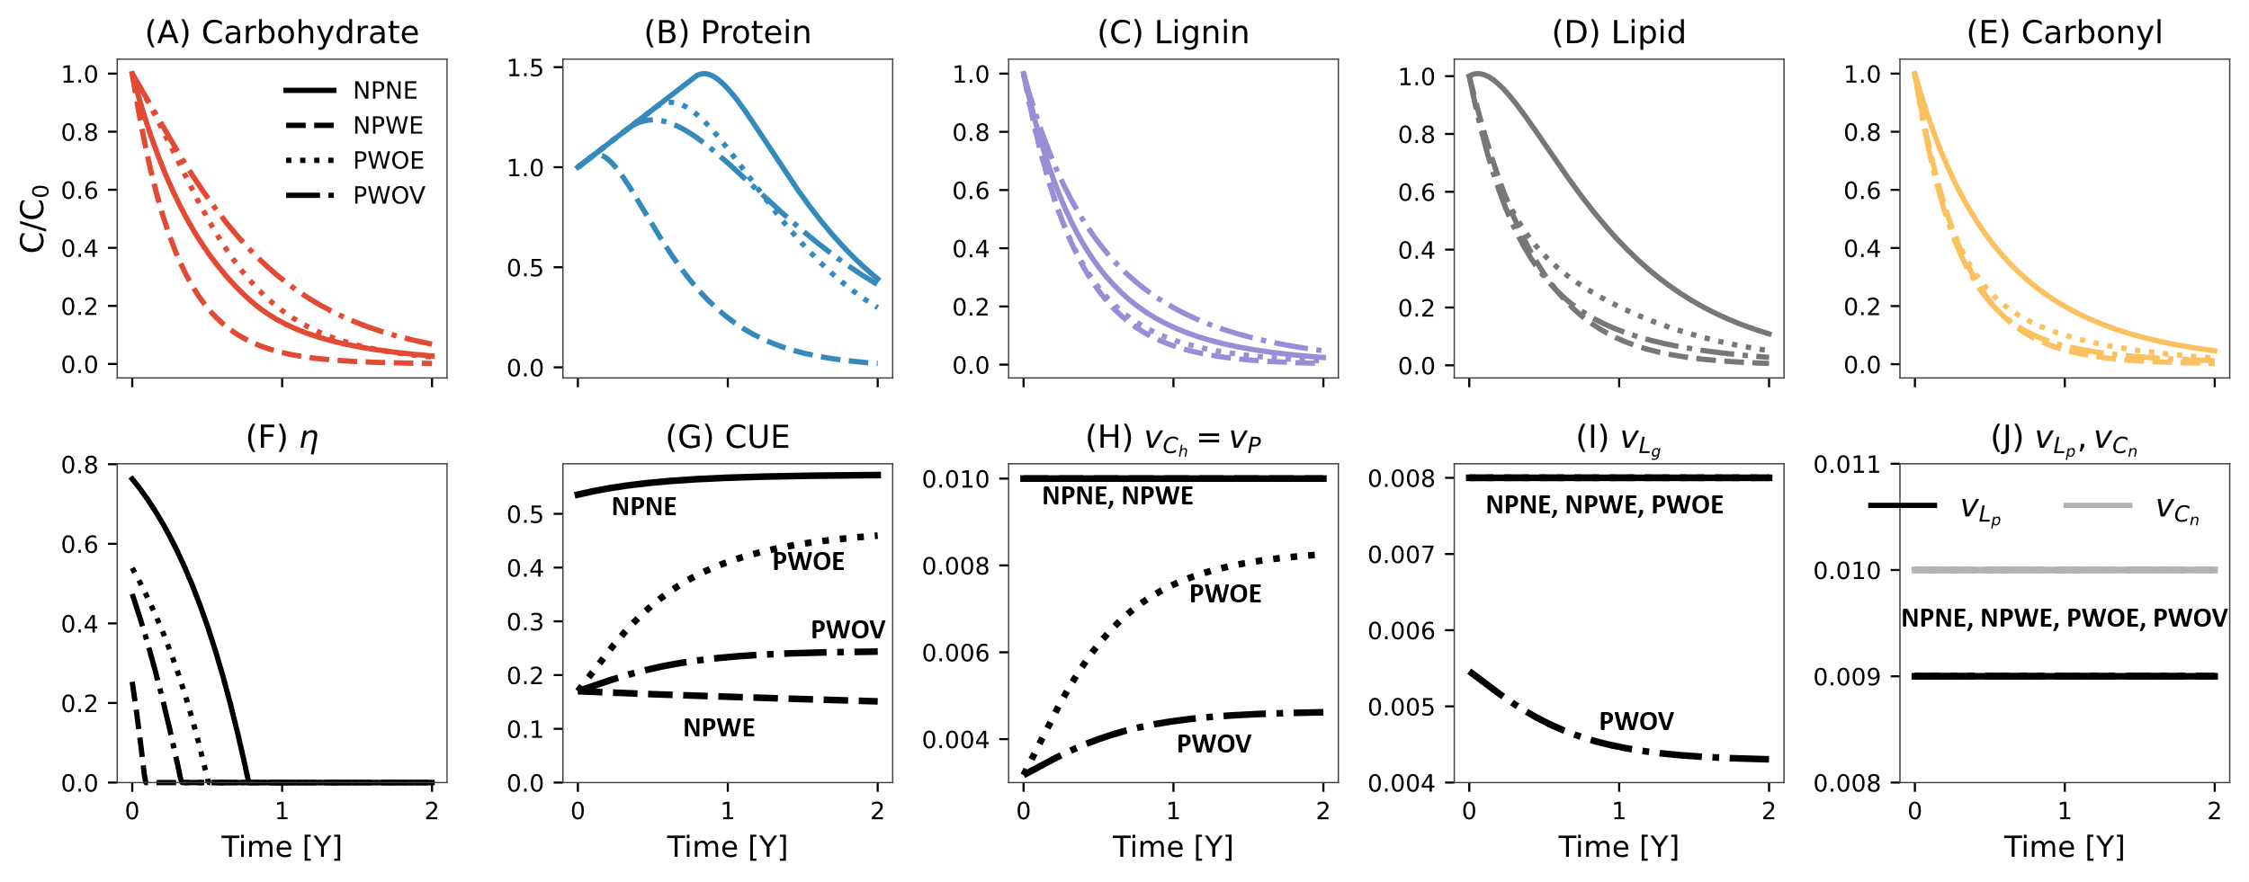  
Figure Simulated temporal variation in carbohydrate (A), protein (B), lignin (C) lipid (D), and carbonyl (E) pools, and N retention factor $η$ (F) in four model scenarios using N-retention strategy. Different model scenarios are illustrated using different line styles. The bottom panels (G-J) show the variation with lignin fraction of C use efficiency (CUE) (G), rate constants for carbohydrate ($v_{C_{h}}$) and protein ($v_{P}$) (H), lignin ( $v_{L_{g}})$ (I), and rate constants for lipid ($v_{L_{p}}$) and carbonyl pools ($v_{C_{n}}$) (J). Model parameters and initial conditions used in simulation were $v_{C_{h}}, v_{P},v_{L_{pg}},{v_{L}}_{p}, v_{C_{n}}=$ [0.01, 0.01, 0.008, 0.009, 0.01] d-1, and =1e-5 gN d-1; initial fraction of carbohydrate, protein, lignin, lipid, and carbonyl pools were 0.43,0.02,0.3,0.2,0.05 in gCgC-1, respectively; and the initial mass of litter was considered to be 1g on dry weight basis. Model legends are the same as in Figure 2.

## Comparable model predictions are observed regardless of the model scenario and nitrogen adaptation strategy

To test the usefulness of a lignin rate modifier, we fitted the four different model scenarios to compiled NMR data, using model implementing both microbial nitrogen adaptation (N retention and flexible CUE) strategies separately. In Figure 4, we illustrate the observed and predicted mass loss across five litter pools for six selected litter types assuming only the N retention strategy. We obtained comparable model calibration results for the five litter pools across the four model scenarios (Figure 4), despite the high variability in the initial C fractions estimated using the molecular mixing model and NMR data (Table S3). Overall, model calibration resulted in high accuracy with NSE values >0.95 and RMSE <0.02 (Figures 5, see also Figures S5 and S6). Many litter datasets showed an NSE > 0, indicating that the model performance is more accurate than merely using the mean of the observed values (Figure 6). Moreover, the same datasets had an RMSE close to zero, indicating a robust data-model fit (Figure 6). Model fits were influenced by data availability or by the uncertainty in assigning certain NMR spectra to the chemical classes. For instance, in each scenario, the model consistently performed poorly for protein and carbonyl pools, with around 30% and 12% of datasets having negative NSE values, respectively. When comparing the two N adaptation strategies, all model scenarios performed similarly (Figure 6), indicating that current data–model integration frameworks—even with detailed representations of litter chemistry—are insufficient to determine when a specific N adaptation strategy is active.

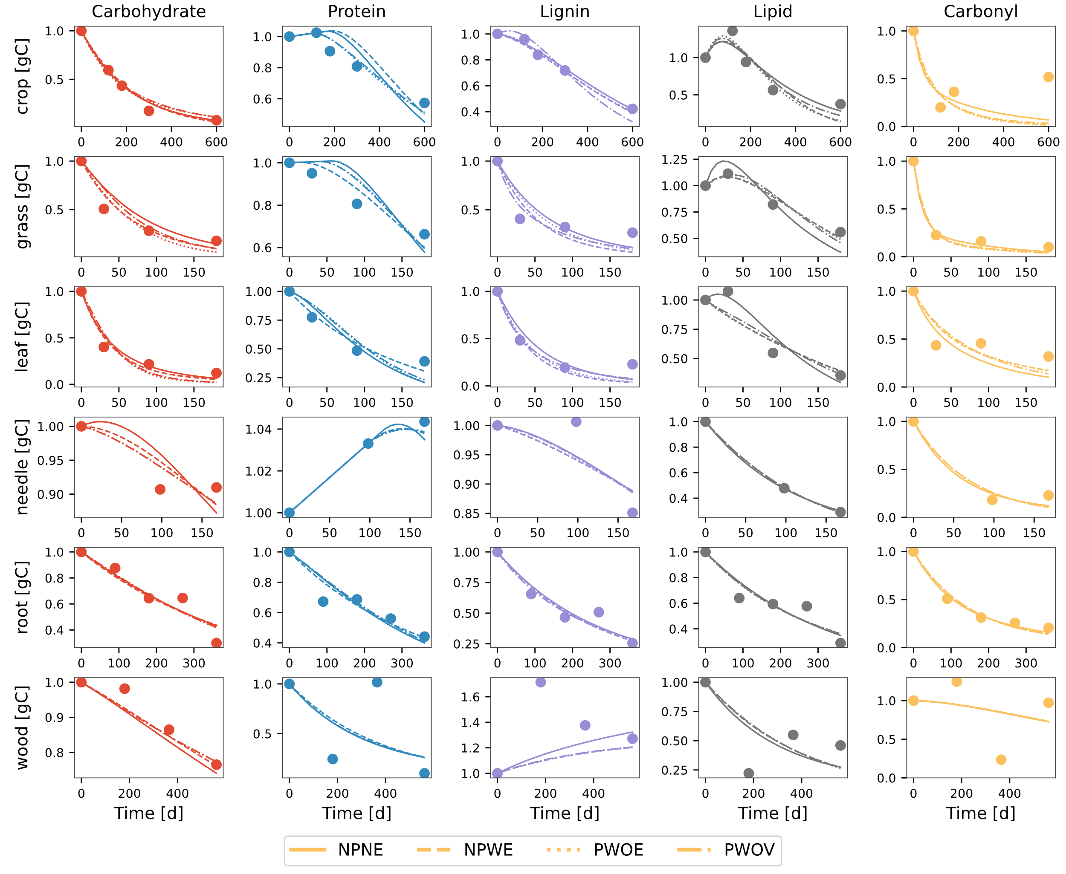

Figure 4 Comparison of modeled (different line styles) and observed (circles) changes in five litter pools (carbohydrate, protein, lignin, lipid, and carbonyl) for various litter types. The data points for the crop litter is from wheat straw buried at 15cm depth in sandy loam soil from Li et al. (2020); grass and leaf litter samples are of A. mauritanicus and A. unedo species, respectively, from Bonanomi et al. (2013); needle litter is from P. radiata from Almendros et al. (2000); root litter samples are fine roots of M. macclurei from Wang et al. (2013); and wood litter of Mulga twigs from Mathers et al. (2007). Different line styles are for four model variants.

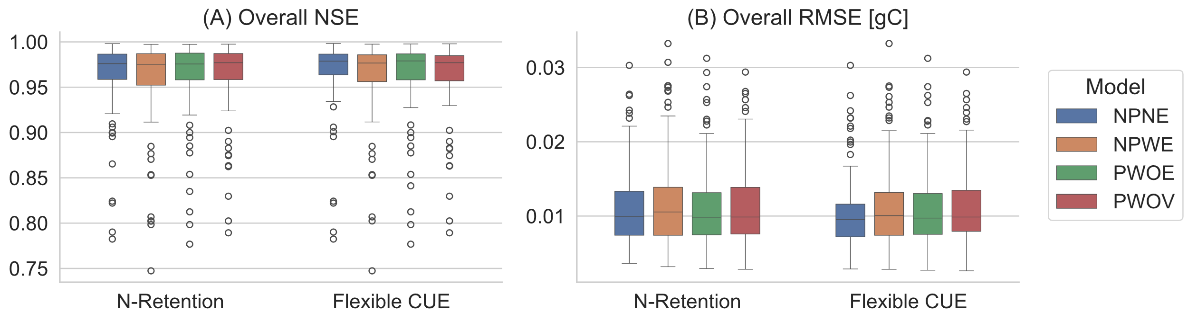

Figure Boxplot of Nash–Sutcliffe modeling efficiency coefficient (NSE) (A) and root mean square error (RMSE in gC) (B) for overall model performance under four model scenarios and two N adaptation strategies.

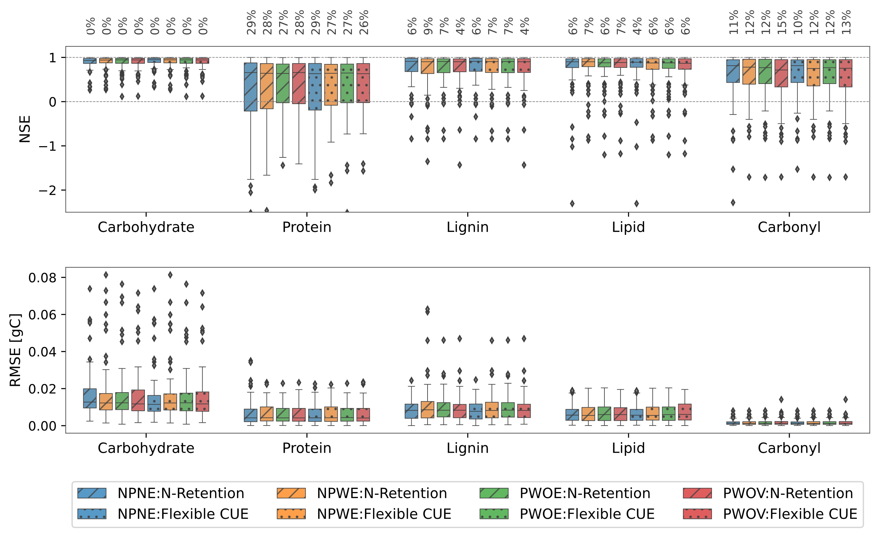

Figure Boxplot of Nash–Sutcliffe modeling efficiency coefficient (NSE) (A) and root mean square error (RMSE in gC) (B) for five pools for four model scenarios. Diagonal lines and dots within boxes denote NSE and RMSE for two N adaptation strategies, N-retention and Flexible CUE, respectively. The box shows the interquartile range (IQR), with the median marked by a horizontal line. Whiskers extend to values within 1.5 times the IQR from the quartiles and outliers beyond the whiskers are indicated by individual markers. The percentage number in panel A show the % of litter dataset having NSE<0. Model legends are the same as in Figure 4.

## Detailed description of litter chemistry constrains of kinetic model parameters

One persistent issue common to all biogeochemical models is equifinality, or the inability to properly constrain model parameters, especially kinetic parameters. By adding more realism to the litter chemical composition compared to traditional models—and supported by comparably detailed chemistry data— we tested whether our proposed models could aid in constraining kinetic parameters. Data fitting across the four scenarios resulted in slight variations in estimated kinetic parameters for all litter pools. The two nitrogen adaptation strategies did not reduce uncertainty in the estimation of the decay rate constants relative to the simpler models (Figure 7). The kinetic rate constants for the individual litter pools ranged from 0.005 to 0.05 d⁻¹. These values were within the range reported for carbohydrates, proteins, and lignin in previous studies using traditional measures of litter chemistry and modeling frameworks different than ours (Chakrawal et al., 2024a; Manzoni et al., 2021). The extreme values observed in the boxplots (Figure 7) correspond to the parameter bounds imposed during the calibration process. In some cases, these boundary values coincided with poor model fits.

Across all model scenarios, we found a negative relationship between both initial and average microbial CUE and the initial litter C:N ratio (Figure 8). This pattern was consistent under the flexible CUE strategy as this strategy decreases CUE under N limited conditions irrespective of the incurred cost of producing oxidative enzymes. Under the N-retention strategy, the negative relationship was found in all scenarios except the no-protection, no-enzyme-cost (NPNE) case, where both initial and average CUE remained elevated and showed no sensitivity to increasing litter C:N ratio.

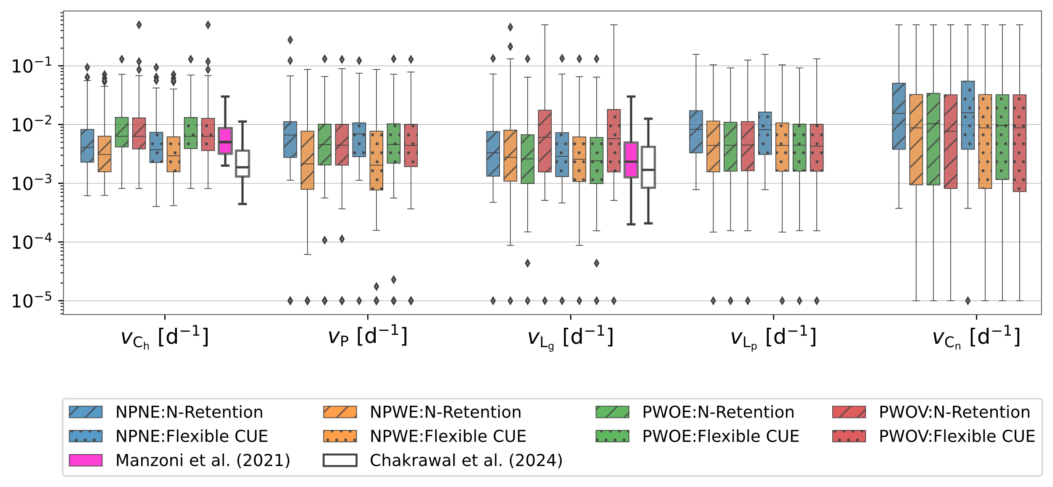

Figure 7 Distribution plot of estimated model parameters, i.e., the uptake rate constant for carbohydrate ($v_{C_{h}}$), protein ($v_{P}$), lignin ($v_{Lg}$), lipid ($v_{L_{p}}$), and carbonyl ($v_{C_{n}}$) for four model scenarios as different box colors and two N adaptation strategies as different box styles. Note the log transformed value on Y-axis for each variable. The box plots illustrated by black and purple lines are the rates of carbohydrates, proteins, and oxidizable (representative of lignin) pools, respectively, taken from Manzoni et al. (2021), and nonaromatic (representative of carbohydrates and proteins) and aromatic (representing lignin and other aromatic compounds) pools from Chakrawal et al. (2024a). Model legends are the same as in Figure 2.

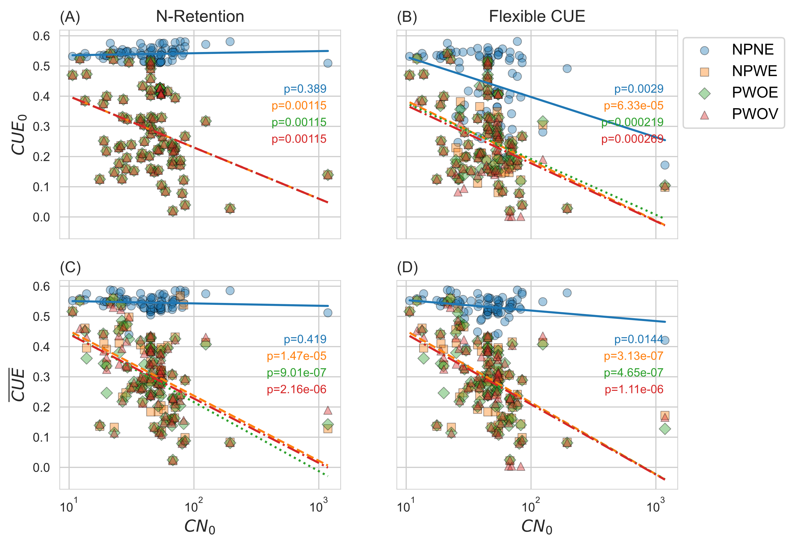

Figure 8 Variation in initial ($CUE_{0}$) and temporal average ($\overline{CUE}$) carbon use efficiency under N retention and flexible CUE adaptation strategy for four model scenarios.

# Discussion:

## Using 13C NMR data to constrain litter decomposition model

We demonstrated the utility of chemically resolved ¹³C NMR data for constraining parameters in a litter decomposition model that tracks the dynamics of five key chemical classes: carbohydrates, proteins, lignins, lipids, and carbonyls. To our knowledge, this is the first study to employ ¹³C NMR-derived compound class-specific mass loss data to predict the temporal trajectories of these pools across diverse litter types and ecosystems.

Unlike previous modeling efforts that relied on chemical descriptors based on proximate analysis (e.g., water-soluble, acid-soluble, and acid-insoluble fractions) derived from coarse analytical methods to parameterize models (e.g., (Chakrawal et al., 2024b; Preston and Trofymow, 2015)), we used molecular-level mass loss estimates. A major limitation of the proximate analysis approach is that the operationally defined fractions do not correspond directly to the chemically meaningful pools used in mechanistic decomposition models (Preston and Trofymow, 2015; Chakrawal et al., 2024b). Chakrawal et al. (2024a) partially addressed this by relating acid-unhydrolyzable fractions to aromatic C from NMR spectra as a proxy for lignin decay, yet this still required indirect mapping. In contrast, our approach directly incorporates NMR-derived estimates of compound class mass loss into model calibration, allowing a more chemically explicit evaluation of model performance across functional chemical groups. This enables a direct assessment of the model's ability to resolve decomposition trajectories for biochemically distinct litter components. Only one other study to date, by Incerti et al. (2017), has employed NMR data for model calibration, focusing on spectral chemical shift classes. However, because chemical shifts do not directly represent compound-specific decay dynamics, their approach is less directly comparable to biogeochemical models designed for Earth system applications.

Our model achieved high fidelity to observed data, with NSE values >0.95 and RMSE <0.02 across litter pools (Figures 5 and 6), indicating strong predictive performance and robust parameter estimation. However, for some litter sample model performance was influenced by data limitations and uncertainty in assigning specific NMR spectra to litter fractions. In some cases, studies did not report the CN ratio of litter, requiring protein fraction to be estimated using the MMM model. Additionally, certain studies only reported the summed intensities of broad chemical shift regions—particularly those above 145 ppm—potentially introducing errors in estimating carbonyl fraction. These limitations contributed to poor model fit for the protein and carbonyl mass loss (Figure 6). Comparing two N adaptation strategies also showed minimal differences in model performance (Figure 5), suggesting that even detailed litter chemistry provides limited constraint on microbial response to N limited condition, as issue also highlighted by Manzoni et al (2021). Additionally, the estimated rate constants for carbohydrate, protein, and lignin pools (Figures 5 and 6) were broadly consistent with those reported in Chakrawal et al (2024a) and Manzoni et al (2021), suggesting that for these compound classes, traditional proximate analyses may be as effective as NMR-based inputs for capturing decomposition dynamics.

We also examined whether the model, constrained by NMR-derived litter chemistry, could reproduce known patterns of microbial CUE across varying litter CN ratios—a key ecological response linked to nutrient availability and stoichiometric imbalance. Previous studies have shown that microbial CUE tend to decline as litter CN ratio increases, reflecting microbial responses to N limitation (Manzoni et al., 2008). This trend is typically attributed to flexible CUE strategies, where microbes increase overflow respiration to maintain biomass stoichiometry, resulting in lower CUE for N poor litters (Schimel and Weintraub, 2003). Our simulations reproduce this pattern across all scenarios using a flexible CUE strategy, including the no-protection, no-enzyme-cost (NPNE) scenario, where both initial and average CUE decreased with increasing litter CN ratio (Figure 8 B and D). In contrast, under the N retention strategy, microbial necromass is recycled internally, removing the need for overflow respiration and decoupling N limited growth response from CUE reduction.

In both N adaptation strategies, the maximum CUE was constrained by the oxidation state of litter carbon, while reductions in CUE were primarily driven by the energetic cost of producing oxidative enzymes. Notably, in the NPNE scenario—where enzyme production costs were excluded—initial and average CUE remained relatively high, even for litters with high initial CN ratios. These findings suggest that enzyme production costs are critical for constraining microbial efficiency under nutrient-limited conditions and excluding physiological trade-offs can lead to poorly constrained CUE estimates. Specifically, they highlight the importance of incorporating chemically resolved litter inputs and mechanistic constraints such as enzyme investment is essential for accurately capturing emergent CUE patterns and for improving our understanding of microbial responses to litter quality and nutrient availability. More broadly, this work demonstrates the value of ¹³C NMR data as a constraint for process-based litter decomposition models used in land surface modeling frameworks.

## Lignin modifier does not improve model calibration, but can improve process understanding

Lignin provides chemical protection to labile components such as cellulose and hemicellulose and increases the energetic cost of decomposition through the demand for oxidative enzymes (Kirk and Farrell, 1987; Talbot and Treseder, 2012). Several decomposition models incorporate lignin protection through empirical rate modifiers (Campbell et al., 2016; Chakrawal et al., 2024a; Manzoni et al., 2021; Robertson et al., 2019), often derived from coarse litter descriptors such as the lignocellulose index (e.g., (Herman et al., 2008; Moorhead et al., 2013), however, no study has explicitly evaluated whether incorporating a lignin modifier improves model performance against empirical data. Our results indicate that incorporating a lignin-based rate modifier does not substantially improve model calibration performance. All model scenarios, including those with and without lignin protection and oxidative enzyme costs, produced comparable simulation outcomes and strong agreement with observed decomposition dynamics (Figures 5 and 6).

This raises an important modeling consideration: when and why should a lignin rate modifier be included? From a parsimony perspective, simpler models that exclude lignin protection should be favored if they yield equivalent predictive skill. Yet, models incorporating lignin modifiers offer mechanistic hypotheses that can be empirically tested, particularly regarding trade-offs between oxidative enzyme production and microbial growth efficiency under chemically complex substrates. Moreover, to effectively constrain microbial parameters such as CUE, it is essential to account for the costs associated with enzyme production; incorporating a lignin modifier enables a mechanistic representation of this cost, linking substrate chemistry to observed physiological trade-offs.

In our study, incorporating a lignin-based rate modifier serves to balance biological realism with model parsimony—a key objective of recent eco-evolutionary approaches to decomposition modeling (Schwarz et al., 2025). This formulation aligns with the "return-on-investment" concept, where the degradation of chemically complex substrates such as lignin depends on whether the energy gained from decomposition offsets the metabolic cost of oxidative enzyme production. While our simulations show that models with and without lignin protection perform similarly against observed data, including a lignin modifier enables mechanistic representation of substrate-driven trade-offs in microbial allocation strategies. Moreover, our scenario 4 with a temporally variable lignin decay rate reflects empirical observations of changing investment in oxidative enzymes during decomposition, providing a more process-informed model structure (Chakrawal et al., 2024a).

To further interpret these structural differences in model, the four modeling scenario can be thought of as distinct metabolic response that decomposer communities may deploy simultaneously or independently at different stages of litter decomposition. For example, in the NPNE scenario, where lignin imposes no constraint and oxidative enzyme production incurs no cost, microbes exhibit high CUE) and rapid substrate uptake—resulting in accelerated litter loss but prolonged N limitation due to elevated microbial demand (Figure 3). In contrast, scenarios with enzyme production costs (NPWE, PWOE, PWOV) show reduced early-stage CUE, suppressing microbial growth and N demand, and thus increasing N retention as necromass. The protective role of lignin in PWOE and PWOV further restricts early carbohydrate and protein loss, delaying CUE recovery until lignin declines (Figure 3). These results highlight how exploring contrasting scenarios allows us to infer nutrient condition-dependent microbial strategies and better constrain model parameters and improve our process-level understanding of decomposition dynamics.

# Conclusions

Microbial regulation of decomposition, including high costs of oxidative enzyme production and shielding of carbohydrates and proteins by lignin, plays a critical role in controlling litter turnover. Our analysis shows that different model scenarios, representing alternative microbial strategies, can explain observed litter decomposition dynamics with similar accuracy. The integration of detailed ¹³C NMR chemical composition data, rather than relying on traditional bulk indices, allows for a more mechanistic representation of litter chemical complexity and its influence on microbial activity. This approach advances our understanding of how chemical diversity and microbial metabolism interact to shape decomposition trajectories. Future efforts should focus on coupling such detailed biochemical data with models that explicitly incorporate microbial energetics and trait variation to improve predictions of soil carbon dynamics under environmental change.

# Author Contributions

A.C. designed the study, developed the model framework, conducted the analyses, and led manuscript writing. L.C.R. assisted with interpretation of results and writing results and discussion. S.M. contributed to model conceptualization, interpretation of results, and manuscript revisions. All authors reviewed, edited, and approved the final version of the manuscript.

# Code availability statement

# References

Alcalde, M., 2015. Engineering the ligninolytic enzyme consortium. Trends Biotechnol. 33, 155–162. https://doi.org/10.1016/j.tibtech.2014.12.007

Almendros, G., Dorado, J., González-Vila, F.J., Blanco, M.J., Lankes, U., 2000. 13C NMR assessment of decomposition patterns during composting of forest and shrub biomass. Soil Biol. Biochem. 32, 793–804. https://doi.org/10.1016/S0038-0717(99)00202-3

Beidler, K.V., Phillips, R.P., Andrews, E., Maillard, F., Mushinski, R.M., Kennedy, P.G., 2020. Substrate quality drives fungal necromass decay and decomposer community structure under contrasting vegetation types. J. Ecol. 108, 1845–1859. https://doi.org/10.1111/1365-2745.13385

Bonanomi, G., Incerti, G., Giannino, F., Mingo, A., Lanzotti, V., Mazzoleni, S., 2013. Litter quality assessed by solid state 13C NMR spectroscopy predicts decay rate better than C/N and Lignin/N ratios. Soil Biol. Biochem. 56, 40–48. https://doi.org/10.1016/j.soilbio.2012.03.003

Boye, K., Noël, V., Tfaily, M.M., Bone, S.E., Williams, K.H., Bargar, J.R., Fendorf, S., 2017. Thermodynamically controlled preservation of organic carbon in floodplains. Nat. Geosci. 10, 415–419. https://doi.org/10.1038/ngeo2940

Campbell, E.E., Parton, W.J., Soong, J.L., Paustian, K., Hobbs, N.T., Cotrufo, M.F., 2016. Using litter chemistry controls on microbial processes to partition litter carbon fluxes with the Litter Decomposition and Leaching (LIDEL) model. Soil Biol. Biochem. 100, 160–174. https://doi.org/10.1016/j.soilbio.2016.06.007

Chakrawal, A., Calabrese, S., Herrmann, A.M., Manzoni, S., 2022. Interacting Bioenergetic and Stoichiometric Controls on Microbial Growth. Front. Microbiol. 13.

Chakrawal, A., Lindahl, B.D., Manzoni, S., 2024a. Modelling optimal ligninolytic activity during plant litter decomposition. New Phytol. n/a. https://doi.org/10.1111/nph.19572

Chakrawal, A., Lindahl, B.D., Qafoku, O., Manzoni, S., 2024b. Comparing plant litter molecular diversity assessed from proximate analysis and 13C NMR spectroscopy. Soil Biol. Biochem. 197, 109517. https://doi.org/10.1016/j.soilbio.2024.109517

del Cerro, C., Erickson, E., Dong, T., Wong, A.R., Eder, E.K., Purvine, S.O., Mitchell, H.D., Weitz, K.K., Markillie, L.M., Burnet, M.C., Hoyt, D.W., Chu, R.K., Cheng, J.-F., Ramirez, K.J., Katahira, R., Xiong, W., Himmel, M.E., Subramanian, V., Linger, J.G., Salvachúa, D., 2021. Intracellular pathways for lignin catabolism in white-rot fungi. Proc. Natl. Acad. Sci. 118, e2017381118. https://doi.org/10.1073/pnas.2017381118

Dignac, M.-F., Kögel-Knabner, I., Michel, K., Matzner, E., Knicker, H., 2002. Chemistry of soil organic matter as related to C : N in Norway spruce forest (Picea abies(L.) Karst.) floors and mineral soils. J. Plant Nutr. Soil Sci. 165, 281–289. https://doi.org/10.1002/1522-2624(200206)165:3<281::AID-JPLN281>3.0.CO;2-A

Ding, Y., Shi, Z., Ye, Q., Liang, Y., Liu, M., Dang, Z., Wang, Y., Liu, C., 2020. Chemodiversity of Soil Dissolved Organic Matter. Environ. Sci. Technol. 54, 6174–6184. https://doi.org/10.1021/acs.est.0c01136

Hall, S.J., Ye, C., Weintraub, S.R., Hockaday, W.C., 2020. Molecular trade-offs in soil organic carbon composition at continental scale. Nat. Geosci. 13, 687–692. https://doi.org/10.1038/s41561-020-0634-x

Hedges, J.I., Baldock, J.A., Gélinas, Y., Lee, C., Peterson, M.L., Wakeham, S.G., 2002. The biochemical and elemental compositions of marine plankton: A NMR perspective. Mar. Chem. 78, 47–63. https://doi.org/10.1016/S0304-4203(02)00009-9

Herman, J., Moorhead, D., Berg, B., 2008. The relationship between rates of lignin and cellulose decay in aboveground forest litter. Soil Biol. Biochem. 40, 2620–2626. https://doi.org/10.1016/j.soilbio.2008.07.003

Janssen, P.H.M., Heuberger, P.S.C., 1995. Calibration of process-oriented models. Ecol. Model., Modelling Water, Carbon and Nutrient Cycles in Forests 83, 55–66. https://doi.org/10.1016/0304-3800(95)00084-9

Kirk, T.K., Farrell, R.L., 1987. Enzymatic “Combustion”: The Microbial Degradation of Lignin. Annu. Rev. Microbiol. 41, 465–501. https://doi.org/10.1146/annurev.mi.41.100187.002341

Knicker, H., Lüdemann, H.-D., 1995. N-15 and C-13 CPMAS and solution NMR studies of N-15 enriched plant material during 600 days of microbial degradation. Org. Geochem. 23, 329–341. https://doi.org/10.1016/0146-6380(95)00007-2

Kögel-Knabner, I., 2002. The macromolecular organic composition of plant and microbial residues as inputs to soil organic matter. Soil Biol. Biochem. 34, 139–162. https://doi.org/10.1016/S0038-0717(01)00158-4

Kothawala, D.N., Kellerman, A.M., Catalán, N., Tranvik, L.J., 2021. Organic Matter Degradation across Ecosystem Boundaries: The Need for a Unified Conceptualization. Trends Ecol. Evol. 36, 113–122. https://doi.org/10.1016/j.tree.2020.10.006

Li, D., Li, Z., Zhao, B., Zhang, J., 2020. Relationship between the chemical structure of straw and composition of main microbial groups during the decomposition of wheat and maize straws as affected by soil texture. Biol. Fertil. Soils 56, 11–24. https://doi.org/10.1007/s00374-019-01397-0

Liski, J., Palosuo, T., Peltoniemi, M., Sievänen, R., 2005. Carbon and decomposition model Yasso for forest soils. Ecol. Model. 189, 168–182. https://doi.org/10.1016/j.ecolmodel.2005.03.005

Manzoni, S., Chakrawal, A., Spohn, M., Lindahl, B.D., 2021. Modeling Microbial Adaptations to Nutrient Limitation During Litter Decomposition. Front. For. Glob. Change 4. https://doi.org/10.3389/ffgc.2021.686945

Manzoni, S., Jackson, R.B., Trofymow, J.A., Porporato, A., 2008. The Global Stoichiometry of Litter Nitrogen Mineralization. Science 321, 684–686. https://doi.org/10.1126/science.1159792

Mathers, N.J., Jalota, R.K., Dalal, R.C., Boyd, S.E., 2007. 13C-NMR analysis of decomposing litter and fine roots in the semi-arid Mulga Lands of southern Queensland. Soil Biol. Biochem. 39, 993–1006. https://doi.org/10.1016/j.soilbio.2006.11.009

Mattila, H., Österman-Udd, J., Mali, T., Lundell, T., 2022. Basidiomycota Fungi and ROS: Genomic Perspective on Key Enzymes Involved in Generation and Mitigation of Reactive Oxygen Species. Front. Fungal Biol. 3.

Moorhead, D.L., Lashermes, G., Sinsabaugh, R.L., Weintraub, M.N., 2013. Calculating co-metabolic costs of lignin decay and their impacts on carbon use efficiency. Soil Biol. Biochem. 66, 17–19. https://doi.org/10.1016/j.soilbio.2013.06.016

Nelson, P.N., Baldock, J.A., 2005. Estimating the molecular composition of a diverse range of natural organic materials from solid-state 13C NMR and elemental analyses. Biogeochemistry 72, 1–34. https://doi.org/10.1007/s10533-004-0076-3

Normand, A.E., Turner, B.L., Lamit, L.J., Smith, A.N., Baiser, B., Clark, M.W., Hazlett, C., Kane, E.S., Lilleskov, E., Long, J.R., Grover, S.P., Reddy, K.R., 2021. Organic Matter Chemistry Drives Carbon Dioxide Production of Peatlands. Geophys. Res. Lett. 48, e2021GL093392. https://doi.org/10.1029/2021GL093392

Preston, C., Trofymow, J., 2015. The chemistry of some foliar litters and their sequential proximate analysis fractions. BIOGEOCHEMISTRY 126, 197–209. https://doi.org/10.1007/s10533-015-0152-x

Preston, C., Trofymow, J., Canadian Intersite Decomposition E, 2000. Variability in litter quality and its relationship to litter decay in Canadian forests. Can. J. Bot.-Rev. Can. Bot. 78, 1269–1287. https://doi.org/10.1139/b00-101

Preston, C.M., Nault, J.R., Trofymow, J.A., 2009. Chemical changes during 6 years of decomposition of 11 litters in some Canadian forest sites. Part 2. 13C abundance, solid-state 13C NMR spectroscopy and the meaning of “lignin.” Ecosystems 12, 1078–1102. https://doi.org/10.1007/s10021-009-9267-z

Preston, Caroline M., Nault, J.R., Trofymow, J.A., Smyth, C., CIDET Working Group, 2009. Chemical Changes During 6 Years of Decomposition of 11 Litters in Some Canadian Forest Sites. Part 1. Elemental Composition, Tannins, Phenolics, and Proximate Fractions. Ecosystems 12, 1053–1077. https://doi.org/10.1007/s10021-009-9266-0

PRESTON, C.M., SHIPITALO, S.-E., DUDLEY, R.L., FYFE, C.A., MATHUR, S.P., LEVESQUE, M., 1987. Comparison of 13c cpmas nmr and chemical techniques for measuring the degree of decomposition in virgin and cultivated peat profiles. Can. J. Soil Sci. 67, 187–198. https://doi.org/10.4141/cjss87-016

Robertson, A.D., Paustian, K., Ogle, S., Wallenstein, M.D., Lugato, E., Cotrufo, M.F., 2019. Unifying soil organic matter formation and persistence frameworks: the MEMS model. Biogeosciences 16, 1225–1248. https://doi.org/10.5194/bg-16-1225-2019

Schimel, J.P., Weintraub, M.N., 2003. The implications of exoenzyme activity on microbial carbon and nitrogen limitation in soil: A theoretical model. Soil Biol. Biochem. 35, 549–563. https://doi.org/10.1016/S0038-0717(03)00015-4

Schwarz, E., Abs, E., Chakrawal, A., Rodriguez, L.C., Quévreux, P., Manzoni, S., 2025. Eco-evolutionary optimality in soil organic matter models. https://doi.org/10.22541/au.174006386.62850460/v1

Shimizu, M., Yuda, N., Nakamura, T., Tanaka, H., Wariishi, H., 2005. Metabolic regulation at the tricarboxylic acid and glyoxylate cycles of the lignin-degrading basidiomycetePhanerochaete chrysosporium against exogenous addition of vanillin. PROTEOMICS 5, 3919–3931. https://doi.org/10.1002/pmic.200401251

Talbot, J.M., Treseder, K.K., 2012. Interactions among lignin, cellulose, and nitrogen drive litter chemistry–decay relationships. Ecology 93, 345–354. https://doi.org/10.1890/11-0843.1

Wang, H., Liu, S., Wang, J., Shi, Z., Lu, L., Guo, W., Jia, H., Cai, D., 2013. Dynamics and speciation of organic carbon during decomposition of leaf litter and fine roots in four subtropical plantations of China. For. Ecol. Manag. 300, 43–52. https://doi.org/10.1016/j.foreco.2012.12.015

Zhang, J., Elser, J.J., 2017. Carbon:Nitrogen:Phosphorus Stoichiometry in Fungi: A Meta-Analysis. Front. Microbiol. 8. https://doi.org/10.3389/fmicb.2017.01281

Table Summary of litter types, climate, and initial litter chemical composition from the complied studies included in this analysis.

|  |  |  |  |  |  |  |  |  |  |  |  |  |  |
| --- | --- | --- | --- | --- | --- | --- | --- | --- | --- | --- | --- | --- | --- |
| Study | Litter types | Climate | Incubation length  (day) | MAT  (oC) | MAP (mm) | C  (gC/g d.w. litter) | N_conc  (gN/g d.w. litter) | CN ratio  (gC/gN) | Carbohydrate  (gC/g d.w. litter) | Protein  (gC/gC d.w. litter) | Lignin  (gC/gC d.w. litter) | Lipid  (gC/gC d.w. litter) | Carbonyl  (gC/gC d.w. litter) |
| Almendros et al. 2000 | needle, leaf | Mediterranean | 168 | 14.500 | 415 | 410 - 544 | 7 - 28 | 17.607 - 77.714 | 0.293 - 0.624 | 0.041 - 0.180 | 0.068 - 0.338 | 0.069 - 0.393 | 0 - 0.072 |
| Bonanomi et al 2013 | grass, leaf, needle | Mediterranean | 180 | 16.500 | 1080 | 354 - 487 | 11.297 - 35.290 | 12.200 - 40.100 | 0.357 - 0.600 | 0.079 - 0.260 | 0.028 - 0.332 | 0.059 - 0.298 | 0.003 - 0.052 |
| Certini et al 2023 | grass | Mediterranean | 720 | 9.200 | 1273 | 500 | 11.043 - 46.946 | 10.651 - 45.278 | 0.403 - 0.619 | 0.070 - 0.298 | 0.099 - 0.190 | 0.106 - 0.179 | 0.015 - 0.021 |
| De Marco et al. 2021 | leaf | Mediterranean | 403 - 810 | 16 | 756 | 487.830 - 615.090 | 4.300 - 7.250 | 70.700 - 124.310 | 0.337 - 0.430 | 0.026 - 0.045 | 0.173 - 0.246 | 0.324 - 0.365 | 0.003 - 0.014 |
| Gao et al 2016 | crop residue | Warm Temperate | 360 | 15.500 | 985 | 479.800 | 8.800 | 54.523 | 0.652 | 0.058 | 0.148 | 0.142 | 0 |
| Li et al 2020 | crop residue | Warm Temperate | 600 | 13.900 | 597 | 450.100 - 469.100 | 8.410 - 8.610 | 53.520 - 54.483 | 0.681 - 0.747 | 0.058 - 0.059 | 0.119 - 0.132 | 0.057 - 0.098 | 0.017 - 0.031 |
| Mathers et al., 2007 | crop residue, leaf, grass, wood, roots | Warm Temperate | 562 | 21 | 516 | 409.300 - 500 | 1.680 - 29.755 | 15.100 - 274.600 | 0.510 - 0.752 | 0.012 - 0.210 | 0.015 - 0.202 | 0.035 - 0.266 | 0.009 - 0.039 |
| McKee et al., 2016 | grass | Warm Temperate | 1096 | 12.800 | 835 | 500 |  |  | 0.696 | 0.061 | 0.042 | 0.171 | 0.030 |
| Ono et al 2009 | leaf | Warm Temperate | 1095 | 21 | 516 | 516.200 - 522.800 | 11.197 - 11.592 | 45.100 - 46.100 | 0.394 - 0.508 | 0.069 - 0.070 | 0.225 - 0.314 | 0.199 - 0.222 |  |
| Ono et al 2011 | leaf | Warm Temperate | 1095 | 21 | 516 | 592.700 - 609.400 | 10.617 - 11.141 | 53.200 - 57.400 | 0.373 - 0.387 | 0.055 - 0.060 | 0.237 - 0.261 | 0.310 - 0.317 |  |
| Ono et al 2013 | leaf | Warm Temperate | 1095 | 21 | 516 | 500 |  |  | 0.347 - 0.513 | 0 - 0.074 | 0.196 - 0.347 | 0.224 - 0.340 | 0 - 0.002 |
| Pastorelli et al 2021 | leaf | Mediterranean | 365 | 9.200 | 1273 | 500 | 10.417 | 48 | 0.465 | 0.066 | 0.315 | 0.122 | 0.033 |
| Preston et al. 2009 | needle, leaf, grass, wood | Cold Temperate | 2190 | 6.700 | 978 | 438 - 497 | 0.400 - 12.800 | 38.828 - 1182.500 | 0.374 - 0.698 | 0.003 - 0.082 | 0.129 - 0.342 | 0 - 0.272 | 0.002 - 0.039 |
| Quideau et al 2005 | leaf | Warm Temperate | 733 | 14.400 | 678 | 467 - 499 | 6.970 - 8.836 | 55 - 68 | 0.356 - 0.461 | 0.047 - 0.058 | 0.199 - 0.269 | 0.175 - 0.290 | 0.052 - 0.073 |
| Sjöberg et al 2004 | needle | Cold Temperate | 559 | 7.600 | 1440 | 500 | 9.091 - 21.739 | 23 - 55 | 0.412 - 0.431 | 0.058 - 0.138 | 0.318 - 0.359 | 0.129 - 0.145 | 0.003 - 0.007 |
| Wang et al 2013 | leaf, roots | Warm Temperate | 360 | 21 |  | 392.600 - 574.200 | 6 - 15.700 | 33.083 - 80.483 | 0.258 - 0.443 | 0.039 - 0.096 | 0.206 - 0.508 | 0.103 - 0.390 | 0.020 - 0.054 |
| Wang et al 2019 | leaf | Warm Temperate | 450 | 19.880 | 1000 | 509 - 512 | 2.629 - 6 | 84.833 - 194.729 | 0.188 - 0.219 | 0.016 - 0.037 | 0.456 - 0.486 | 0.259 - 0.299 | 0.011 - 0.028 |